Lesson Plan
“Your Success Story Program” Classroom Visit

F2f or Virtual

If your classroom visit is virtual, we will discuss the platform based upon what your school is currently using for virtual instruction.

Directions for Teachers Hosting Players

BEFORE Visit
- Teachers will deliver this lesson to students prior to the player visit in order to have connect to prior knowledge with the player, as well as discuss their own goals, and how to best use a variety of success strategies to reach those goals. Students will prepare written goals to discuss during the player visit.

- Please contact your school or district PR representative to take photos to post on your district website. See example of Dysart Unified School District: https://www.dysart.org/Sites/Default.aspx?anncID=8361
  - E.g. Minnesota Twins players set goals - Twins baseball player talks with class. Parkview Elementary had special visitors from the Minnesota Twins on Tuesday. Players join 7th and 8th grade classes to talk about goal setting and how to achieve success. The "Your Success Story" program has had ball players visit Parkview since 2010 and the players involved are participants in the Arizona Fall League - a key arena for players to demonstrate their talents before moving up to the majors. As part of the program, students share their passions and their strategies to make their goals a success. The conversations highlight how the players have balanced such issues as nervousness, goal setting, and how to prepare for challenges.

DURING Visit
- Teacher helps facilitate the player visit and promotes high student engagement and interaction.

AFTER Visit
- Teachers have students compose personal narratives describing how they’ll apply what they learned from the player in their own lives as they seek to reach goals.
- Narratives will be picked up by an Extra Innings Foundation rep, and delivered to the player; or, via email based on f2f or virtual visit.

Teacher: |  | Date:
Common Core State Standards/ AZ Content Standards – Writing, Speaking & Listening
- Write narratives to develop real or imagined experiences or events using effective technique, well-chosen details, and well-structured event sequences. Use precise words and phrases, telling details, and sensory language to convey a vivid picture of the experiences, events, setting, and/or characters.
- Engage effectively in a range of collaborative discussions (one-on-one, in groups, and teacher-led) with diverse partners on grade level topics, texts, and issues, building on others’ ideas and expressing their own clearly.

Objective (Explicit):
- Produce clear and coherent writing in which the development, organization, and style are appropriate to task, purpose, and audience.
- Engage effectively in a range of collaborative discussions (one‐on‐one, in groups, and teacher‐led) with diverse partners on grade 8 topics, texts, and issues, building on others’ ideas and expressing their own clearly.

Evidence of Mastery (Measurable):
- Include a copy of the lesson assessment.
- Provide exemplar student responses with the level of detail you expect to see.
- Assign value to each portion of the response.
Active participation in discussion activities (virtual or f2f) during the player visit.
Personal narratives as evidence of mastery.
Sub-objectives, SWBAT (Sequenced from basic to complex):
- How will you review past learning and make connections to previous lessons?
- What skills and content are needed to ultimately master this lesson objective?
- How is this objective relevant to students, their lives, and/or the real world?
(Teachers fill in this blank.)

Key vocabulary:  Success  Significant  Embark  Resilient  Respond |  | Materials:  Before: Written goals students are seeking, ready to discuss with player during his visit.  During player visit: PowerPoint slide of player and a few facts about his career to date.  After: Personal narratives to players.
Opening (state objectives, connect to previous learning, and make relevant to real life)
- How will you activate student interest?
- How will you connect to past learning?
- How will you present the objective in an engaging and student-friendly way?
- How will you communicate its importance and make the content relevant to your students?
When player arrives, please have a slide up on your board showing a photo of him, as well as a brief background.
If in person, be sure to have student name plates on their desks, as well as what they wrote about their goals on their desks, ready to share.
Zoom – names are on screen.
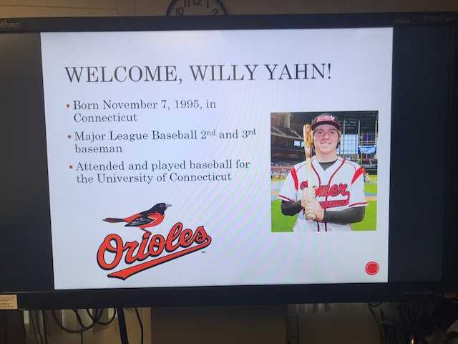
Above: Slide on board ready when player arrives.
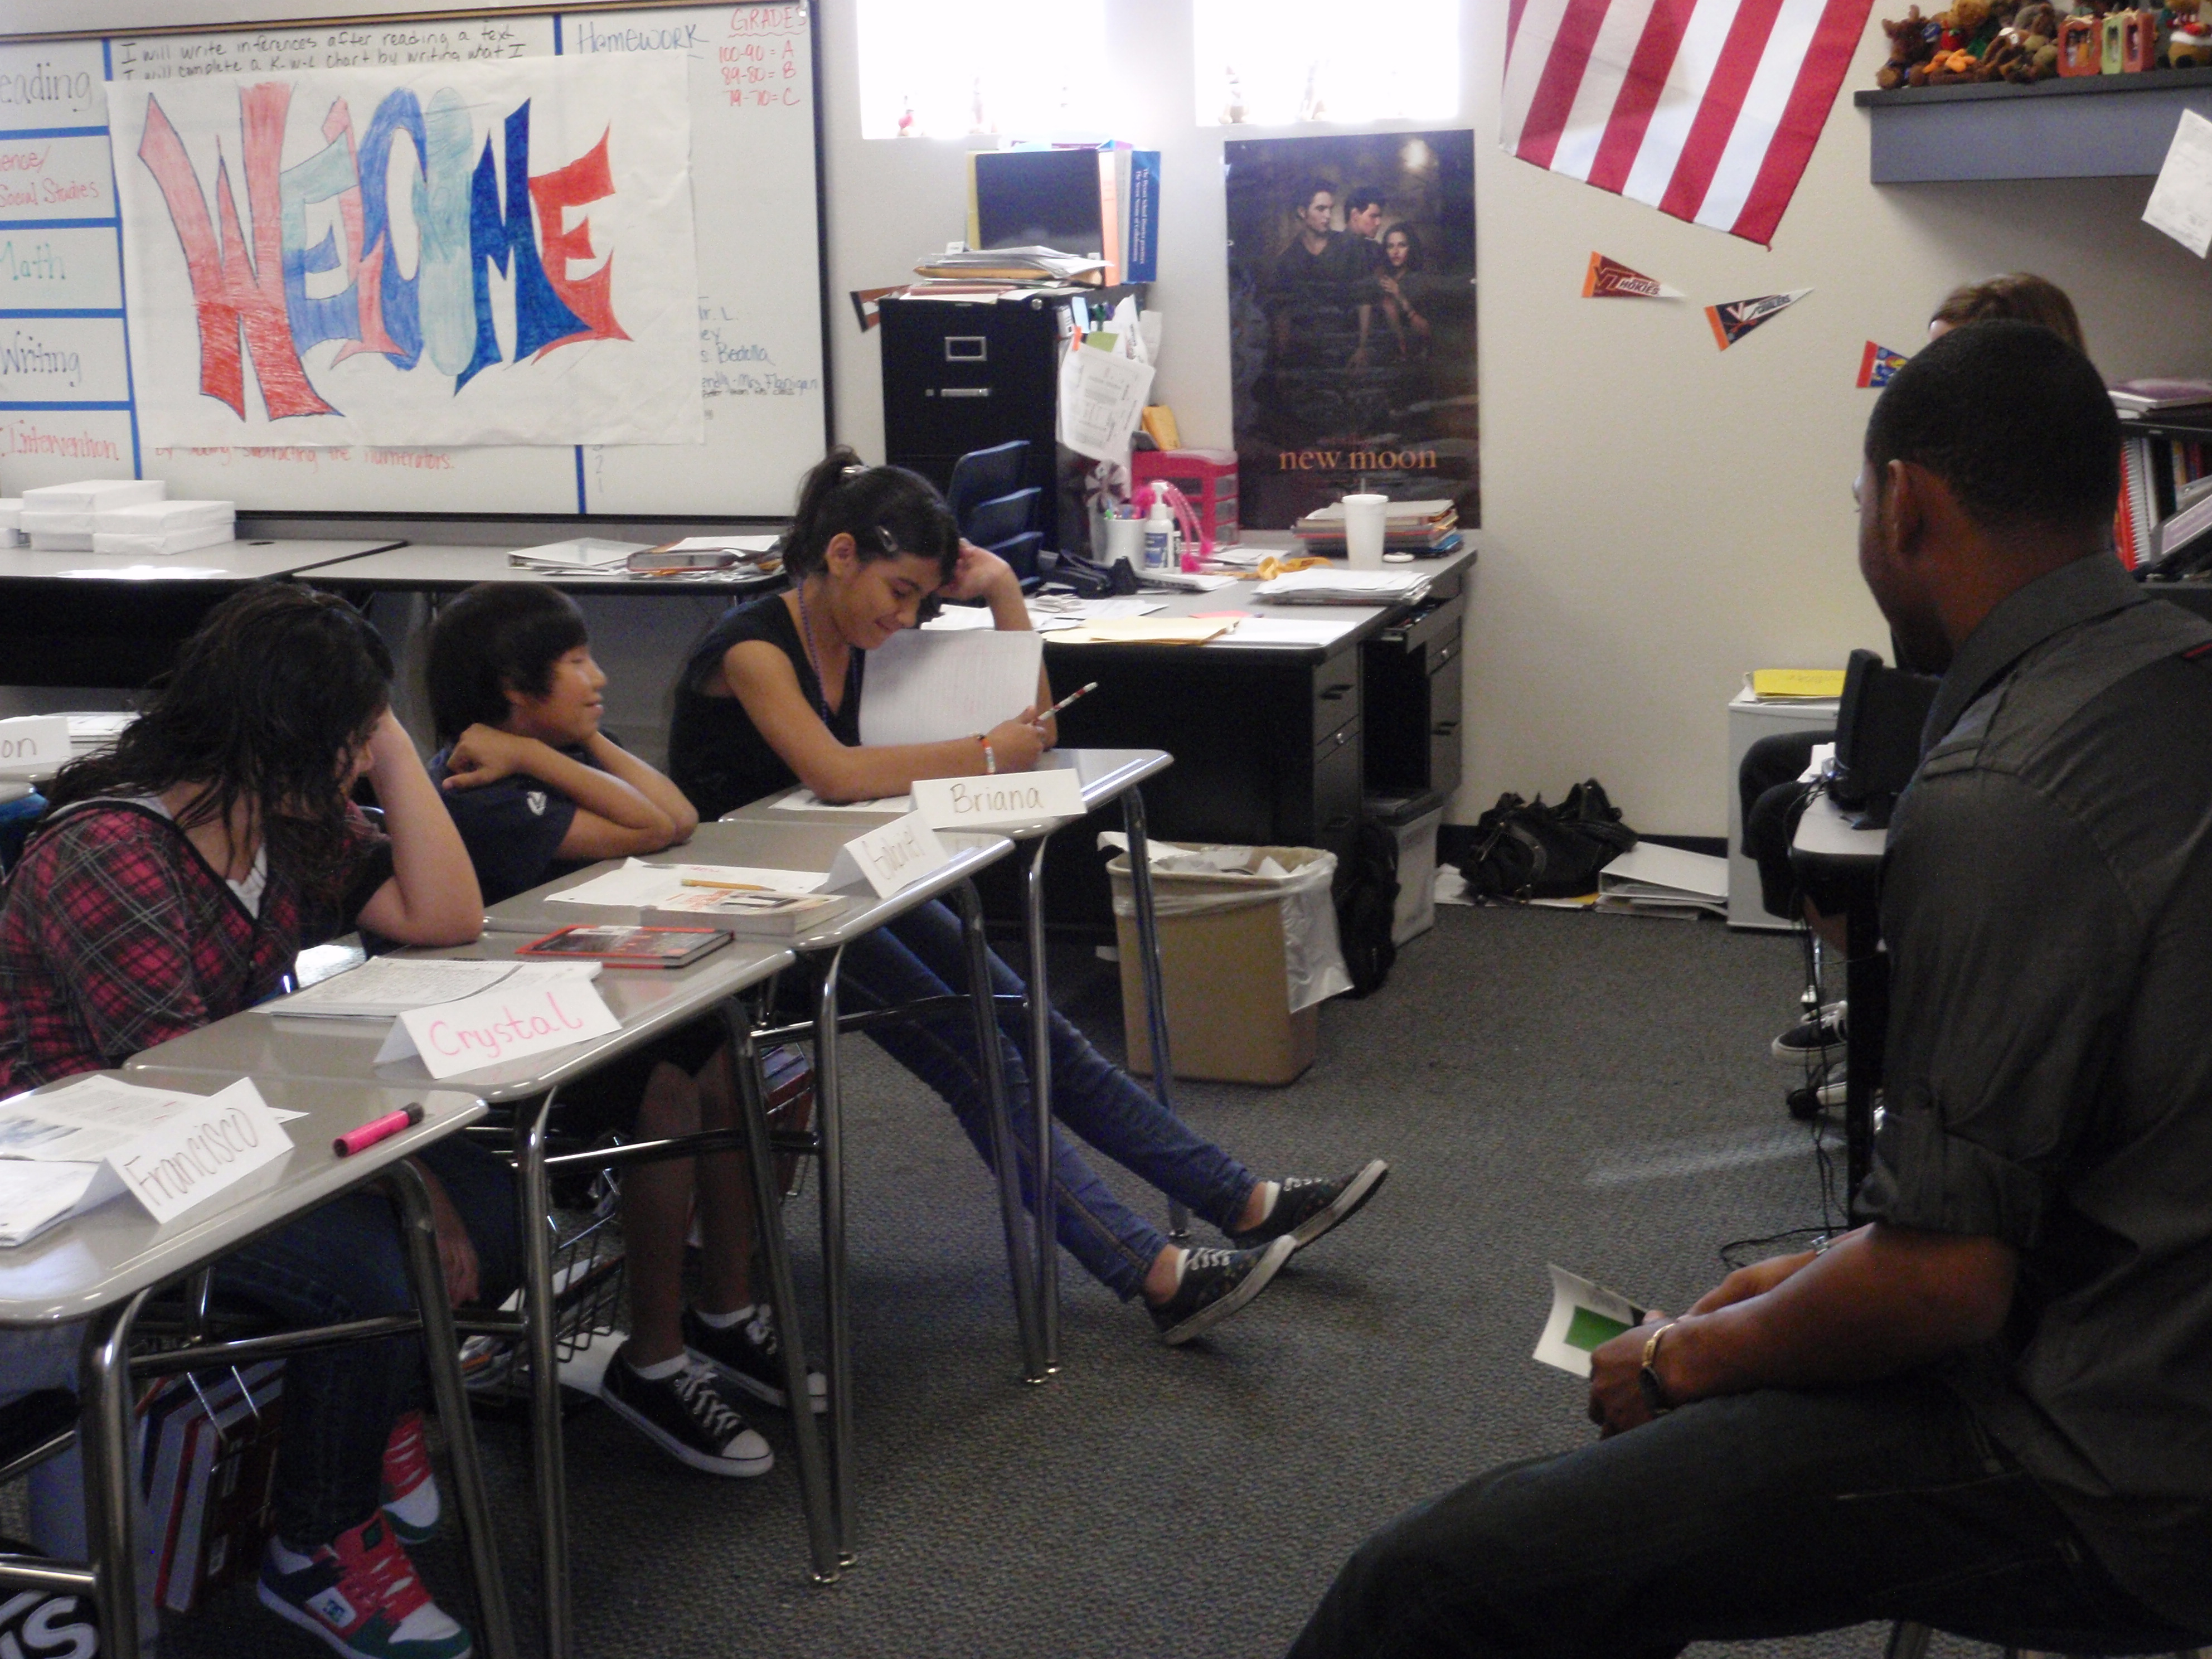
Above: Student writing on desks about their goals ready to share w/player; tri-fold name plates.
Instructional Input | Teacher Will:  - How will you model/explain/demonstrate all knowledge/skills required of the objective?  - What types of visuals will you use?  - How will you address misunderstandings or common student errors?  - How will you check for understanding?  - How will you explain and model behavioral expectations?  - Is there enough detail in this section so that another person could teach it? | Student Will:  - What will students be doing to actively capture and process the new material?  - How will students be engaged?
 | BEFORE  Introduce students to Sam Hairston, and how he used 3 success strategies to reach his goal of becoming the 1st African-American to join the Chicago White Sox in 1951.  Samuel Harding Hairston was a Negro League baseball and Major League Baseball player. He played for the Birmingham Black Barons and the Indianapolis Clowns of the Negro Leagues and played part of one season with the Chicago White Sox as a catcher. He is buried in Birmingham's Elmwood Cemetery.  He worked toward his goal and did not give up.  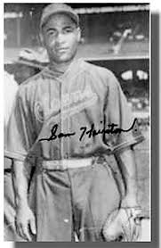 | DURING  Students share what they wrote about their goals with the player.  See video link for an example of player visit and student interactions:  https://youtu.be/eYs21eraYLY  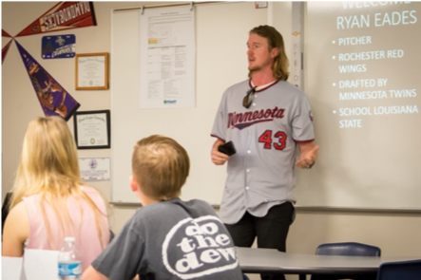
Differentiation Strategy
- What accommodations/modifications will you include for specific students?
- Do you anticipate any students who will need an additional challenge?

Guided Practice | Teacher Will:  - How will you ensure that all students have multiple opportunities to practice new content and skills?  - What types of questions can you ask students as you are observing them practice?  - How/when will you check for understanding?  - How will you provide guidance to all students as they practice?  - How will you explain and model behavioral expectations?  - Is there enough detail in this section so that another person could facilitate this practice? | Student Will:  - How will students practice all knowledge/skills required of the objective, with your support, such that they continue to internalize the sub-objectives?  - How will students be engaged?  - How will you elicit student-to-student interaction?  - How are students practicing in ways that align to independent practice?
 | AFTER  Have students compose personal narratives of how they’ll apply what they learned about success strategies as they strive to reach their own goals.  Contact Dr. Lynn Miller, Extra Innings Foundation, (mobile: 623-707-5065) to let her know letters are ready for pick-up at your school’s front office. Letters will be delivered to the player.  Or, if the visit is via Zoom, please discuss with Dr. Miller how the students will compose and how it’s best for us to get them to the player. | AFTER  Students will compose personal narratives.
Differentiation Strategy
- What accommodations/modifications will you include for specific students?
- Do you anticipate any students who will need an additional challenge?
- How can you utilize grouping strategies?

Independent Practice | Teacher Will:  - How will you plan to coach and correct during this practice?  - How will you provide opportunities for remediation and extension?  - How will you clearly state and model academic and behavioral expectations?  - Did you provide enough detail so that another person could facilitate the practice? | Student Will:  - How will students independently practice the knowledge and skills required by the objective?  - How will students be engaged?  - How are students practicing in ways that align to assessment?  - How are students using self-assessment to guide their own learning?  - How are you supporting students giving feedback to one another?
 | See above re personal narratives. | See above.
Differentiation Strategy
- What accommodations/modifications will you include for specific students?
- Do you anticipate any students who will need an additional challenge?

Closing/Student Reflection/Real-life connections:
- How will students summarize and state the significance of what they learned?
- Why will students be engaged?

Teacher Will: | Student Will:
Differentiation Strategy
- What accommodations/modifications will you provide for specific students?
- How will you anticipate students that need an additional challenge?

Elaborate
- How will students take the learning from Explore and Explain and apply it to a new circumstance or explore a particular aspect of this learning at a deep level?
- How will students use higher order thinking at this stage? (e.g. A common practice in this section is to pose a “what If question”)
- How will all students articulate how their understanding has changed or been solidified?

Teacher Will: | Student Will:
Differentiation Strategy
- What accommodations/modifications will you provide for specific students?
- How will you anticipate students that need an additional challenge?

Evaluate
- How will all students demonstrate mastery of the lesson objective (though perhaps not mastery of the Elaborate content)?
- How will students have an opportunity to summarize the big concepts they learned (separate from the assessment)?
Teacher Will: | Student Will:  BEFORE/DURING: Goals to discuss with player during his visit.  AFTER: Personal narratives
Differentiation Strategy
- What accommodations/modifications will you provide for specific students?
- How will you anticipate students that need an additional challenge?

Closure
- How will you specifically review your lesson’s objectives?
- How will students summarize and state the significance of what they learned?
Teacher Will:  Debrief with students | Student Will:  Compose personal narratives

